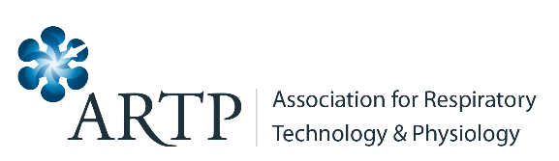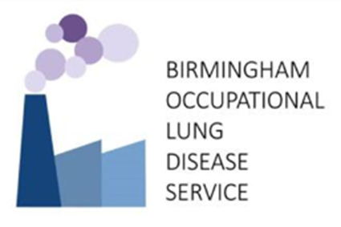

ARTP OCCUPATIONAL ASTHMA COURSE 25th and 26th February 2025
REGISTRATION FORM

Title
First Name
Surname
Job Title
Workplace
Address
Email address
Telephone number

Registration (includes lunch and refreshments during the course) | Amount (£) £
Non-ARTP member Occupational Asthma Course (£450)

ARTP member Occupational Asthma Course (£375)

Total

Dietary Requirements:

PAYMENT INFORMATION

I will pay online within 2 weeks of sending in this registration form

Signature of delegate: Date

Please tell us how you heard about the course

Please complete this form and return to Vicky Moore e-mail: vicky.moore@uhcw.nhs.uk

Cancellation Policy
* All cancellations must be received in writing by post or email
* Cancellations before 10th February 2025 will be subject to a £20 administration charge; no refunds after 10th February 2025 will be given.

