OASYS SETUP INSTRUCTIONS

- Open the folder with the files in it.
- Select ‘Folder options’ in the ‘Tools’ menu.
- You will see a screen as below. Click on the tab marked ‘View’
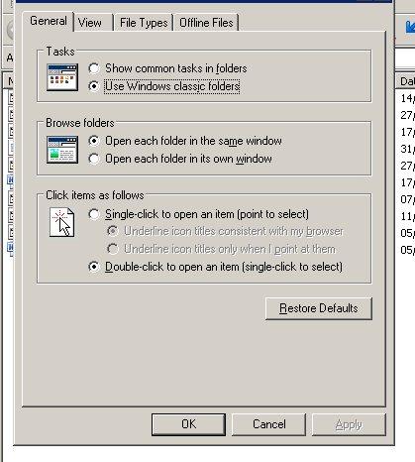
- Make sure that the box ‘Mark extensions for known file types’ is unmarked as below.
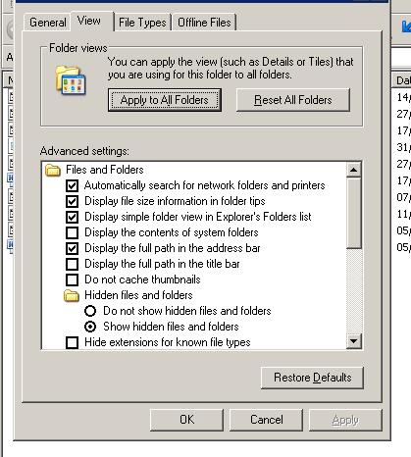
- Click on ‘OK’.
- Now you can rename the SETUP file so that it is called SETUP.EXE.

Hopefully the programme will now work. Sorry about the complicated instructions. They are a way to get around virus protection programmes that delete executable files.

